**Lab 6 Report**

**Assigned Design:**

**San Diego Coupons: https://couponssandiego.com/**

**University of advancing technology: https://www.uat.edu/**

**Name: Hamza Mehmood**

**Class & Section: BS-SE 6TH (Evening)**

**Roll number: SP-21-110**

**Assigned Design: https://www.uat.edu/**

**Assessment:** Use/apply think aloud protocol, observational study, task analysis.Visual Design Elements, Color, Typography, Layout, Visual Hierarchy, Contrast and Visual Balance, Designing for Accessibility, Navigation, Readability.

Do attach screenshots with respective analysis

**Task and report with screenshots:**

1. **Planning and conducting a usability test:** Students will plan and design a usability test for a selected website or app. They will define the research objectives, develop test scenarios or tasks, and recruit participants. Students will conduct the usability test, ensuring that participants' interactions and feedback are observed and recorded.
2. **Collecting and analyzing usability data:** Students will collect data during the usability test, which may include video recordings, observation notes, questionnaires, or task completion rates. They will learn how to analyze the collected data to identify patterns, trends, and usability issues. Students will interpret the data to gain insights into the strengths and weaknesses of the design.
3. **Identifying usability issues and providing recommendations:** Based on the analysis of usability data, students will identify specific usability issues and prioritize them based on their impact on user experience. They will generate recommendations for design improvements, considering usability principles and best practices. Students will provide actionable suggestions to address the identified usability issues and enhance the overall user experience
4. **Presenting findings and recommendations:** Students will prepare a usability test report to present their findings and recommendations. The report will include a summary of usability test objectives, methods used, key findings, prioritized usability issues and recommended design changes. Students will effectively communicate their insights and recommendations in a clear & concise manner, targeting different stakeholders such as designers, developers and project managers.
5. **Visual Design**:

* **Analysis**: The website’s visual design is outdated and does not follow current design trends. The website’s color scheme is dull and unappealing, which makes it difficult to engage with the content. The typography is inconsistent, making it hard to read and understand the content.
* **Recommendation**: The header should be on the horizontal Side with clear instruction. Also Use a modern color scheme that follows current design trends.
* **Screenshot:** 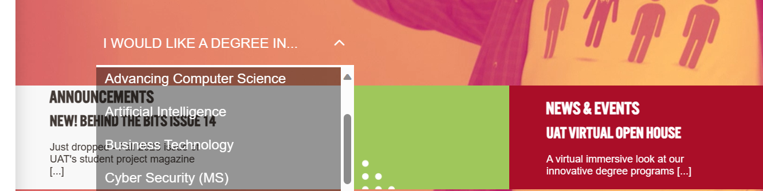

1. **Clarity & Conciseness**:

* **Analysis**: The website’s content is not concise and lacks clarity. The text is too long, making it difficult to read and understand. The website should use shorter sentences and paragraphs to make the content more readable.
* **Recommendation:** Use clear words as well as search need not to be hidden in menu it should be on left on the screen for user usability.
* **Screenshot:**

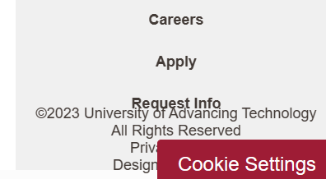

1. **Learnability**:

* **Analysis**: The website’s navigation is not intuitive, making it difficult for users to find what they are looking for. The website should use clear and concise labels for navigation links, and provide a search bar to help users find information quickly.
* **Recommendation:** Place the icons and content at their right place with proper Name and Relativity.
* **Screenshot:**



1. **Grids & Alignments**:

* **Analysis**: The website’s layout is not consistent, making it difficult to navigate. The website should use a grid system to ensure that all elements are aligned properly, which will make it easier for users to scan the content.
* **Recommendation:** The major Flaw is the usage of Horizontal Scrolling causing it difficult to be in align and thus it which should be changed.
* **Screenshot:**

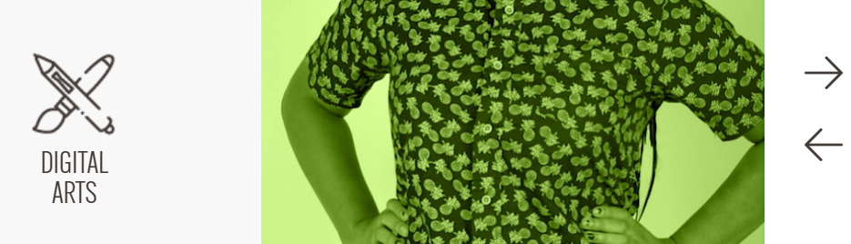

1. **Color Scheme**:

* **Analysis**: The website’s color scheme is not consistent, which makes it difficult to read and understand the content. The website should use a consistent color scheme throughout the site to make it more visually appealing.
* **Recommendation:** Usage of Good Pastel Color Combinations
* **Screenshot:**

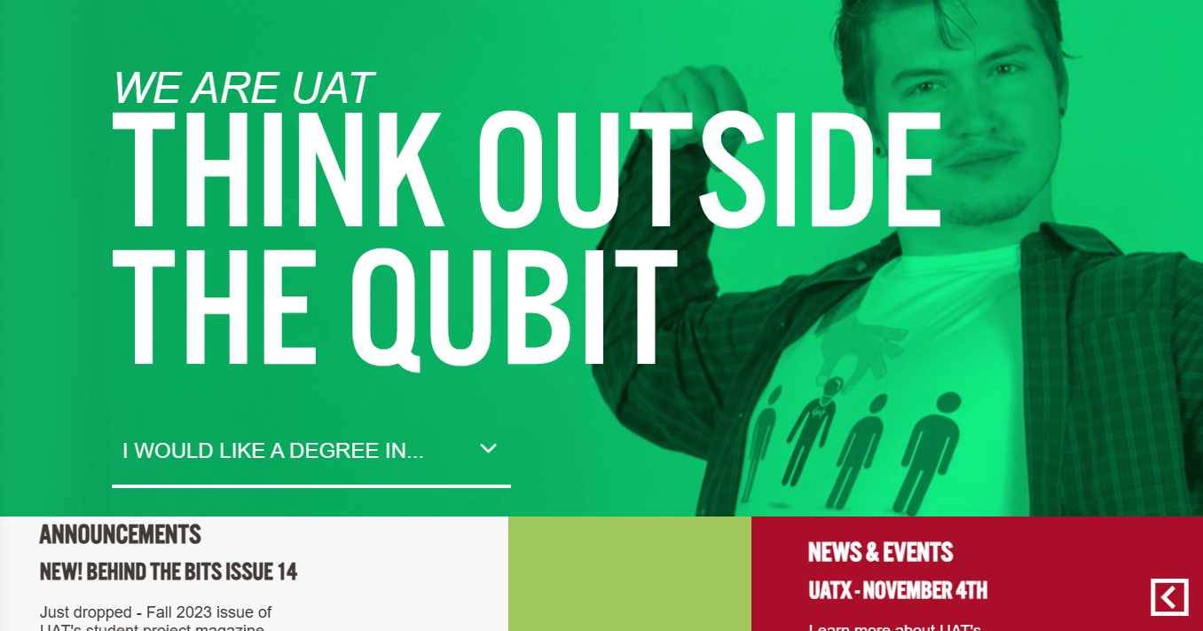

1. **Typography Analysis**:

* **Analysis**: The typography on the website is inconsistent, which makes it difficult to read and understand the content. The website should use a consistent font size and style throughout the site.
* **Recommendation:** The Typo nature should be changed to give a better look.
* **Screenshot:**

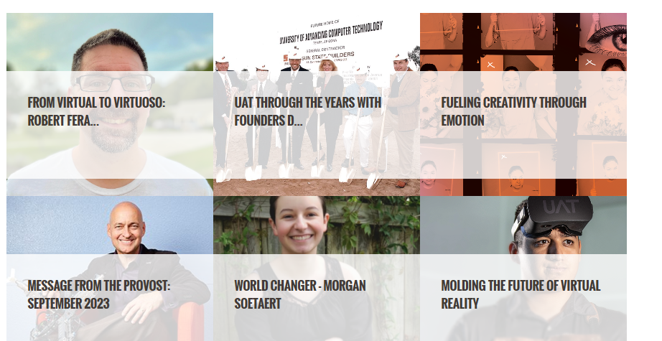

1. **Readability Analysis**:

* **Analysis**: The website’s content is not easy to read, which makes it difficult for users to engage with the content. The website should use shorter sentences and paragraphs, and break up long blocks of text with headings and subheadings.
* **Recommendation:** Place thing at their respective place.
* **Screenshot:**

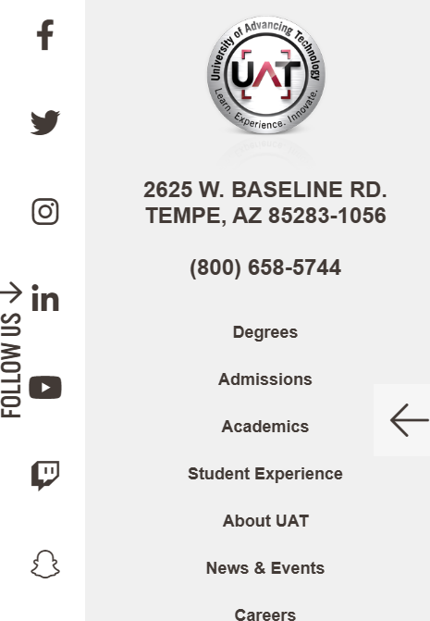

**Major Issues:**

* Outdated visual design
* Inconsistent typography
* Lack of clarity & conciseness
* Poor learnability

**Some Major Recommendations:**

* Use a consistent typography throughout the site.
* Use shorter sentences and paragraphs to improve clarity & conciseness.
* Improve navigation by using clear labels for navigation links.
* Use a grid system to ensure that all elements are aligned properly.
* Break up long blocks of text with headings and subheadings.
* Provide a search bar to help users find information quickly.

**Conclusion:**

In conclusion, the University of Advancing Technology’s website has **several** usability issues that need to be addressed in order to improve user experience. By implementing my recommendations, UAT can create a more engaging and user-friendly website that will help attract more visitors.